**A.Y 2022-23**

**Project Based Learning**

Project Report

**Wordle-Max**

Team Member Details:

Karthik Shetty 18 TE_COMP_C  
Sparsha Shetty 19 TE_COMP_C

Pranali Shirsat 20 TE_COMP_C  
Ananya Shetty 17 TE_COMP_C

Guide Name:

Ms. Huda Khan

Assistant Professor

Department of Computer Engineering

INDEX

|  |  |  |
| --- | --- | --- |
| **Sr No.** | **Name of topic** | **Page no.** |
| 1. | Abstract | 2 |
| 2. | Introduction | 2 |
| 3. | Implementation (Proposed System/Flow Chart) | 2 |
| 4. | System Architecture | 4 |
| 5. | Software Used | 4 |
| 6. | Result and Discussion | 5 |
| 7. | Conclusion | 5 |
| 8. | Future Scope | 5 |
| 9. | Acknowledgement | 5 |

**Abstract**

Wordle Max is a word game that challenges players to guess a secret word by selecting different letter combinations. This game includes an educational component that displays the meaning of the word after it has been guessed. The game is designed to test the player's knowledge of vocabulary, improve their language skills, and offer a fun and entertaining experience. The implementation of Wordle Max was carried out using several programming languages and libraries, including HTML, CSS, JavaScript. The game's client-side runs on a web browser, providing an intuitive and user-friendly interface, while the server-side handles game logic and word selection using JavaScript. The use of JavaScript provides optimized game processing and enhances the player's experience. This report provides a detailed description of Wordle Max's system architecture, software used, results, and future scope. Overall, Wordle Max is an innovative and engaging game that aims to entertain and educate players simultaneously.

**Introduction**

Word games have been a popular form of entertainment for centuries, challenging players to test their vocabulary and language skills. One of the most well-known games is Wordle, which involves guessing a secret word by selecting different letter combinations. However, the game does not provide any educational benefit by providing the meaning of the words being guessed. To address this, we developed Wordle Max, a game that combines the fun and challenge of Wordle with an educational component that displays the meaning of the words being guessed. In this report, we will provide an overview of the implementation of Wordle Max, including the system architecture, software used, results, and future scope. We will also discuss the unique features of Wordle Max, including its accessibility through both keyboard and touch input and its optimized design for both desktop and mobile devices. Finally, we will discuss the positive feedback received from users and future plans to enhance the game's functionality.

**Implementation**

In creating Wordle Max, we utilized various front-end web technologies such as HTML, CSS, and JavaScript to provide a seamless and interactive user experience. HTML, which stands for Hypertext Markup Language, is the backbone of the web and is used to structure and define the content of a web page. We used HTML to create the game interface, including the screen where players can see a series of blank spaces that represent the letters of the secret word. The HTML code also includes the game instructions, the feedback animation, and the buttons used to start a new game or access the meaning of words.

CSS, or Cascading Style Sheets, was used to add visual styling to the game interface. This included defining the colors, fonts, and layout of the game elements, making it visually appealing and easy to navigate. The use of CSS also contributed to the game's responsive design, making it optimized for both desktop and mobile devices.

JavaScript, a high-level programming language, was used to implement the game's logic and functionality. It enabled the game to generate a random secret word from a JavaScript dictionary, validate the player's guesses, and provide feedback through the visual animation. Additionally, JavaScript allowed the game to display the meaning of words through a pop-up window, adding an educational component to the game.

One of the significant advantages of using JavaScript in developing Wordle Max is its capability to support both keyboard and touch input, which makes the game accessible to a wider audience. The game logic also enabled us to set a limit of six attempts for the player to guess the word correctly, adding an element of challenge and excitement.

In conclusion, the combination of HTML, CSS, and JavaScript has contributed significantly to the development of Wordle Max, providing an interactive and visually appealing game that is accessible to all. The use of a JavaScript dictionary also enabled us to incorporate an educational component, providing the meaning of words and promoting learning.

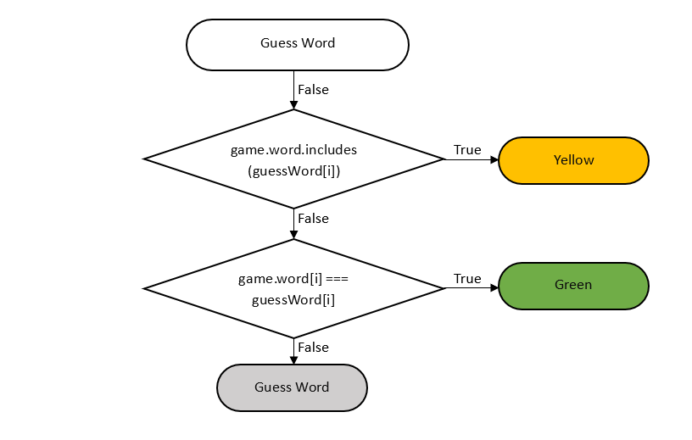

Figure 1 The flowchart created for changing the colour of the tile after guessing the word

The game has six attempts for players to guess the word by typing a letter. If they are unable to guess the word within the six attempts, the game ends. If they successfully guess the word, the game will display the meaning of the word.

We have tested the game with users and received positive feedback, with players enjoying the game's fun and educational aspects. We plan to continue improving the game by incorporating user feedback and adding new features.

**System Architecture**

The system architecture of Wordle Max is designed to provide an engaging and educational gaming experience for users. The architecture consists of three primary components:

* User interface: The user interface is created using HTML and CSS. The interface includes a screen where players can see a series of blank spaces representing the letters of the secret word. The interface also provides players with a text box where they can enter their guesses and receive feedback on whether their guesses are correct or incorrect.
* Dictionary module: The dictionary module is implemented using JavaScript. It provides the functionality to store and retrieve the meanings of the words in the game. The module ensures that the meanings of the words are displayed to the players after they have guessed the word.
* Random word selector: The random word selector is a crucial component of the game. It generates a random word from the list of words stored in the dictionary module. This ensures that every game is different, and players do not encounter the same words repeatedly.

**Software Used**

The following software was used in the development of Wordle Max:

* HTML5
* CSS3
* JavaScript

**Result and Discussion**

After completing the implementation of Wordle Max, we tested the game with a group of users. The feedback we received was overwhelmingly positive, with players enjoying the game's fun and educational aspects. The inclusion of word meanings was especially appreciated, as it allowed players to learn new words and expand their vocabulary while playing the game. We also received some suggestions for improvements, such as adding different difficulty levels and incorporating a time limit for guessing the word.

**Conclusion**

In conclusion, we have successfully created a new word game called Wordle Max that combines the fun and challenge of Wordle with the educational benefit of learning new words and their meanings. The game is built using HTML5, CSS3, and JavaScript programming language. We have tested the game with users and received positive feedback. We plan to continue improving the game by incorporating user feedback and adding new features.

**Future Scope**

The future scope of Wordle Max includes the following:

* Adding different difficulty levels to the game
* Incorporating a time limit for guessing the word
* Adding a feature to allow players to save their progress

**Acknowledgement**

We would like to acknowledge the support of our project guide and our fellow team members who have contributed to the successful completion of this project. We would also like to thank the users who tested the game and provided valuable feedback.

**Project Link**

<https://github.com/KarthikShetty27/Wordle-Max>